PHP Function

String function:

Example #1 strstr()

<?php
$email = 'name@example.com';
$domain = strstr($email, '@');
echo $domain; // prints @example.com
$user = strstr($email, '@', true); // As of PHP 5.3.0
echo $user; // prints name
?>

Example #2 stristr() - Case-insensitive strstr
<?php
$email = 'USER@EXAMPLE.com';
echo stristr($email, 'e'); // outputs ER@EXAMPLE.com
echo stristr($email, 'e', true); // As of PHP 5.3.0, outputs US
?>

Example #3 strpos(string,find,start),stripos()
strpos(original_str, search_str, start_pos)

<?php
echo strpos("Tutorials point simply easy learning !","easy");
?>
ans : 36
echo " string position.................... <br>"
$str = "ignore everything except this (text)";
$start = strpos($str, '('); and : 30
$end = strpos($str, ')', $start + 1);
$length = $end - $start;
$result = substr($str, $start + 1, $length - 1);
echo $result;
echo $end;
example:
<?php

// PHP code to search for a specific string's position
// first occurrence using strpos() case-sensitive function
function Search($search, $string){
$position = strpos($string, $search, 5);
if ($position == true){
return "Found at position: " . $position;
}
else{
return "Not Found";
}
}

// Driver Code
$string = "Welcome to GeeksforGeeks";
$search = "Geeks";
echo Search($search, $string);
?>
Found at position 11
stripos() in PHP(case-insensitive):
syntex:
stripos(original_str, search_str, start_pos)
example:
<?php
// first occurrence using stripos() case-insensitive function
function Search($search, $string){
$position = stripos($string, $search, 5);
if ($position == true){
return "Found at posiion " . $position;
}
else{
return "Not Found";
}
}

// Driver Code
$string = "Welcome to GeeksforGeeks";
$search = "geeks";
echo Search($search, $string);
Output:
Found at position 11

*** find word from string (TRICKS)…::-------

$str = “My name is himel”
if(strpos($str,’is’) !== FALSE)
{
echo “String found”;
}

strrpos() in PHP(search right of the string):
<?php
echo strrpos("I love php, I love php too!","php");
?>
ANS: 19
Example #4 substr(string,start or position,length)
<?php
echo substr("Hello world",10)."<br>";
echo substr("Hello world",1)."<br>";
echo substr("Hello world",3)."<br>";
echo substr("Hello world",7)."<br>";
echo substr("Hello world",-1)."<br>";
echo substr("Hello world",-10)."<br>";
echo substr("Hello world",-8)."<br>";
echo substr("Hello world",-4)."<br>";
?>

output:
d
ello world
lo world
orld
d
ello world
lo world
orld

<?php
echo substr("Hello world",0,10)."<br>";
echo substr("Hello world",1,8)."<br>";
echo substr("Hello world",0,5)."<br>";
echo substr("Hello world",6,6)."<br>";
echo substr("Hello world",0,-1)."<br>";
echo substr("Hello world",-10,-2)."<br>";
echo substr("Hello world",0,-6)."<br>";
?>
output:
Hello worl
ello wor
Hello
world
Hello worl
ello wor
Hello
Example #5 str_replace(‘,’,’-’,$string)
<?php
echo str_replace("world","Peter","Hello world!");
?>
ANS:Hello Peter!

Example #6 String Length, Word Count, Substring Count

$str = 'The letters PHP stand for PHP: Hypertext Preprocessor.PHP originally stood for Personal Home Page Tools.';<?php
// count words in the above example string
echo str_word_count($str); // 16
?>
=>Get String Length
<?php
// get length of example string
echo strlen($str); // 114
?>
=>Count the Number of Words in a String
<?php
// count words in the above example string
echo str_word_count($str); // 16
?>
=>Count Substring Occurrences in String
<?
php echo substr_count($str, 'PHP'); // 3
?>

Example #7 Preg_metch_all(),
// get [–---] value:
$string = "keyword1|guess i'm just looking for [someone|some1|some one] to [chill|hang] with... i'm not a [ho|hoe|slut]
preg_match_all("/\\[(.*?)\\]/", $response, $RESLT);
echo "consol check:".$RESLT[1][0]."-";
echo $RESLT[1][1]."-";
echo $RESLT[1][2];

// get <b>–--- </b> value:
$userinfo = "Name: <b>John Poul</b> <br> Title: <b>PHP Guru</b>";
preg_match_all ("/<b>(.*)<\/b>/U", $userinfo, $pat_array);

print $pat_array[0][0]." <br> ".$pat_array[0][1]."\n";

Exmple-2: get city from string
preg_match('/\bcity\b/', “My city is BD”)

Example #8 COunt multi dimention array

$response = ‘{bbb|ccc e|dfdf dfdf} ddd eee {fff|ggg|www} {fff|ggg|www|1223} hhh {bbb|ccc e|ddddd df}’
preg_match_all("/{(.*)}/U", $response, $RESLT);
echo "consol check:".$RESLT[1][0]."-";
echo $RESLT[1][1]."-";
echo $RESLT[1][2];

// COunt multi dimention array
$typeTotals = array_map("count", $RESLT);
$totalTickets = array_sum($typeTotals);

Topic #8 setcookie()
setcookie(cookie_name, cookie_value, expire time)
Example:
<?php
$cookie_name = "user";
$cookie_value = "John Doe";
setcookie($cookie_name, $cookie_value, time() + (86400 * 30), "/"); // 86400 = 1 day
?>
<?php
if(!isset($_COOKIE[$cookie_name])) {
echo "Cookie named '" . $cookie_name . "' is not set!";
} else {
echo "Cookie '" . $cookie_name . "' is set!<br>";
echo "Value is: " . $_COOKIE[$cookie_name];
}
?>

Topic #9 rand(),rand(min,max);
Example:
<?php
echo(rand() . "<br>");
echo(rand() . "<br>");
echo(rand(10,100));
?>
Output:
28067
10569
46
Topic #10 uniqid()
uniqid(prefix,more_entropy)
Example:
<?php
echo uniqid();
?>
output:
5d4a61c83f3d0
FILE

Topic #1 file_get_contents()
Example:
<?php
echo file_get_contents("test.txt");
?>:
Output: Hello, this is a test file. There are three lines here. This is the last line.
Topic #2 file():

(PHP 4, PHP 5, PHP 7)
file — Reads entire file into an array

Description
file ( string $filename [, int $flags = 0 [, resource $context ]] ) : array

flags
The optional parameter flags can be one, or more, of the following constants:
FILE_USE_INCLUDE_PATH
Search for the file in the include_path.
FILE_IGNORE_NEW_LINES
Omit newline at the end of each array element
FILE_SKIP_EMPTY_LINES
Skip empty lines

Example 1:
<?php
print_r(file("test.txt"));
?>
Output:
Array ( [0] => Hello, this is a test file. [1] => There are three lines here. [2] => This is the last line. )

Example 2:
// the HTML source of a URL.
$lines = file('http://www.example.com/');
// Loop through our array, show HTML source as HTML source; and line numbers too.
foreach ($lines as $line_num => $line) {
echo "Line #<b>{$line_num}</b> : " . htmlspecialchars($line) . "<br />\n";
}

## To READ CSV file (it is similliar to txt file):
if(isset($_SESSION['csv_file_name'])){
$file_data = fopen("../files/".$_SESSION['csv_file_name'],'r');
$output = '';
while ($row = fgetcsv($file_data)) {
$data = array(
'first_name' => $row[0],
'last_name' => $row[1]
);
$query = "INSERT INTO csv_table(firstname,lastname) VALUES('".$data['first_name']."','".$data['last_name']."')";
$result = $this->db->insert($query);
}}

ARRAY:
Ex-1: array_rand():
// the array
$arrX = array("Kay", "Joe","Susan", "Frank");

// get random index from array $arrX
$randIndex = array_rand($arrX);

// output the value for the random index
echo $arrX[$randIndex];

$randI = array_rand($arrX,2);
echo "<br><br>";
echo "random 1:: ".$arrX[$randI[0]]."<br>";
echo "random 2 ::".$arrX[$randI[1]]."<br>";

Ex-2: array_push():
Syntax: array_push(array_name, value1, value2...)
Example:
<?php
$array1= array('Mathematics','Physics');
array_push($array1,'Chemistry','Biology');
print_r($array1);
?>
Ex-3: in_array():

Syntax: in_array(search_value, array_name, mode)

Example:
<?php
$number_list = array('16.10', '22.0', '33.45', '45.45');
if (in_array(22.0, $number_list))
{
echo "'22.0' found in the array";
}
?>
Ex-4: array_intersect_assoc():

Syntax: array_intersect_assoc(array1, array2, .. )

Example :
<?php
$array1 = array("a" => "Orange", "b" => "Apple", "c" => "Banana", "Chery");
$array2 = array("a" =>"Orange", "Banana","Mango");
$result = var_dump(array_intersect_assoc($array1, $array2));
print_r($result)
?>
Copy
Output:
array(1){ ["a"]=> string(6) "Orange"}

Ex-5: array_intersect_key():
Example:
<?php
$array1 = array("Orange" => 1, "Apple" => 2, "Banana" => 3, "Chery" =>4);
$array2 = array("Orange" => 5, "Banana" => 6, "Mango" =>7);
var_dump(array_intersect_key($array1, $array2));
?>
Copy
Output:
array(2) { ["Orange"]=> int(1) ["Banana"]=> int(3)}
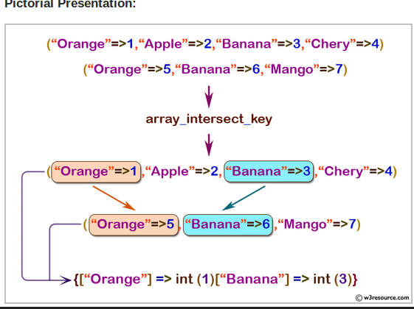
Ex-6: array_search():
Syntex:array_search(value_search, array_name)

Note: GET KEY VALUE By array_search()
Example:
<?php
$fruits = array(0 => 'Orange', 1=> 'Apple', 2 => 'Banana',3 => 'Cherry');
$result = array_search('Cherry', $fruits);
echo $result;
?>
Output: 3
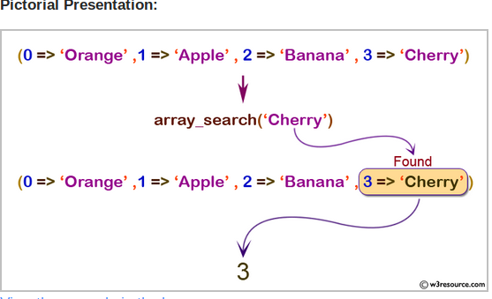

Ex-7:array_diff():
Syntex:array_diff(array1, array2, array3 ...)

Note: array_diff() get difference between two arrays
Example:
<?php
$array1 = array(0=> 'Language', 1=>'Math', 2=>'Science', 3=>'Geography');
$array2 = array(0=> 'Math', 1=>'Science', 2=>'History');
$diff_result = array_diff($array1, $array2);
print_r($diff_result);
?>
Output: Array ( [0] => Language [3] => Geography)
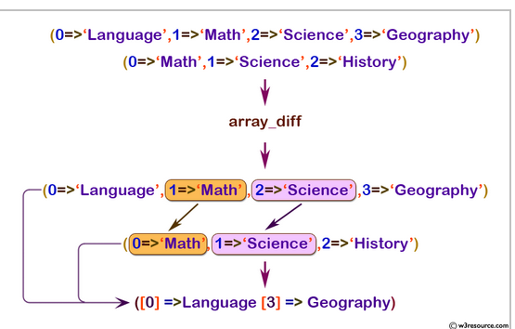

Ex-8:array_password_hash() AND password_verify
():

Description ¶
password_hash ( string $password , int $algo [, array $options ] ) : string

Description ¶
password_verify ( string $password , string $hash ) : bool

when we use password_hash() function to increpted any password then to verify password after login then we use password_verify() function to chaeck both password

EXM 9: array_unique():
Removes duplicate values from an array

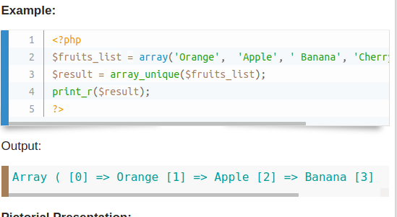

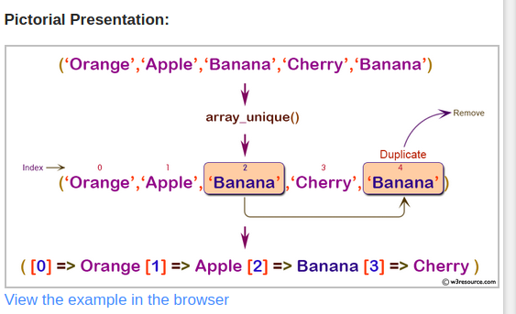

JSON endcode and Decode

Encoding JSON Data in PHP
Url: https://www.tutorialrepublic.com/php-tutorial/php-json-parsing.php

Example1:
Run this code »
<?php
// An associative array
$marks = array("Peter"=>65, "Harry"=>80, "John"=>78, "Clark"=>90);

echo json_encode($marks);
?>
The output of the above example will look like this:
{"Peter":65,"Harry":80,"John":78,"Clark":90}

Example2:
Run this code »
<?php
// An indexed array
$colors = array("Red", "Green", "Blue", "Orange", "Yellow");

echo json_encode($colors);
?>
The output of the above example will look like this:
["Red","Green","Blue","Orange","Yellow"]

Decoding JSON Data in PHP:

Example1:
Run this code »
<?php
// Store JSON data in a PHP variable
$json = '{"Peter":65,"Harry":80,"John":78,"Clark":90}';

var_dump(json_decode($json));
?>
The output of the above example will look something like this:
object(stdClass)#1 (4) { ["Peter"]=> int(65) ["Harry"]=> int(80) ["John"]=> int(78) ["Clark"]=> int(90) }

Example2:
Run this code »
<?php
// Store JSON data in a PHP variable
$json = '{"Peter":65,"Harry":80,"John":78,"Clark":90}';

var_dump(json_decode($json, true));
?>
The output of the above example will look something like this:
array(4) { ["Peter"]=> int(65) ["Harry"]=> int(80) ["John"]=> int(78) ["Clark"]=> int(90) }

Super Global Variabl $_SERVER[]

…………………………. LINK …………………………………….. OR
…… $_SERVER[SCRIPT_FILENAME]………….. OR __FILE__
…………………………………………………………………………………………….

https://abcd/dfd/eerer/google.com
………….dirname()……………...|...basename()…..
………… SERVER['DOCUMENT_ROOT']……….|
** basename(‘google.com’,’.com’); remove .com
** dif between $_SERVER[‘SCRIPT_FILENAME’] and __FILE__
$_SERVER[‘SCRIPT_FILENAME’]: /home/invention/public_html/client/index.php
__FILE__:/home/invention/public_html/client/views/besma/index.tpl.php

Exmaple1: how to get basename into url?

$fullUrl = $_SERVER[‘SCRIPT_FILENAME’];
echo $fullUrl; ///home/invention/public_html/client/marge-number.php
$basename = basename($fullUrl,’.php’);

Exmaple2: how to get dirname into url?

$filePath = realpath(dirname(__FILE__)) OR $_SERVER['DOCUMENT_ROOT'] OR __DIR__;

ex: /home/betamylighth/public_html

include($filePath.’/../abc/def/zyx.php’);

Example 3: IP
function getUserIP()
{
$client = @$_SERVER['HTTP_CLIENT_IP'];
$forward = @$_SERVER['HTTP_X_FORWARDED_FOR'];
$remote = $_SERVER['REMOTE_ADDR'];

if(filter_var($client, FILTER_VALIDATE_IP))
{
$ip = $client;
}
elseif(filter_var($forward, FILTER_VALIDATE_IP))
{ $ip = $forward;}
else
{ $ip = $remote; return $ip}

URL: https://beta.mylighthost.com/bd/reseller
---$_SERVER[‘HTTP_HOST’]--------||---$_SERVER["REQUEST_URI"]

Example 4: $_SERVER["REQUEST_URI"]
URL:https://beta.mylighthost.com/bd/reseller
ouotput:bd/reseller

Example 5: $_SERVER["HTTP_HOST"]
URL:https://beta.mylighthost.com/bd/reseller
ouotput:beta.mylighthost.com

Update: date:
* 07/08/19

